NEPAL MASSIVE QUAKE April 25th 2015
REPORT

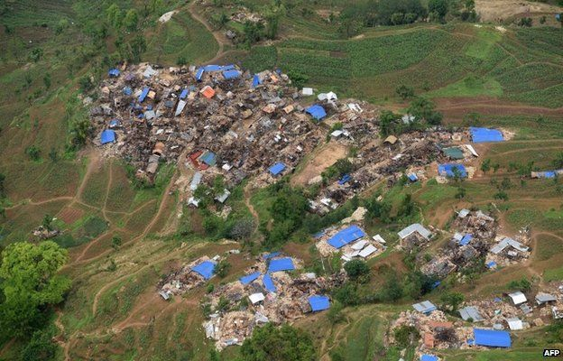
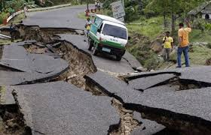
GOOD NEGHBOUR SERVICE ASSOSITION (GONESA) supported by VISPE ITALY

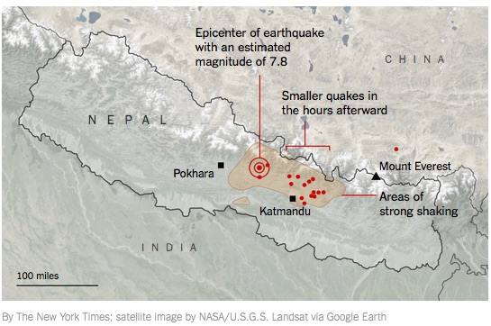
A Strong 7.9 Richter scale earthquake hit Nepal at 11.56 NST on April 25th 2015. It struck approximately 50 miles north of Kathmandu in Gorkha district. It was the most powerful earthquake to strike Nepal since the 2034 Nepal – Bihar earthquake.
The earthquake was followed by many powerful aftershocks and a new earthquake 6.7 Richter hit Nepal on Sunday April 26th. Of the 75 district in Nepal 35 have been affected by the earthquake, 14 of them have been affected severely. Rain falls and aftershocks were factors complicating the rescue efforts with potential secondary efforts like additional landslides and further building collapses being concerns. Impassable roads and damaged communications infrastructure posed substantial challenges to rescue efforts.
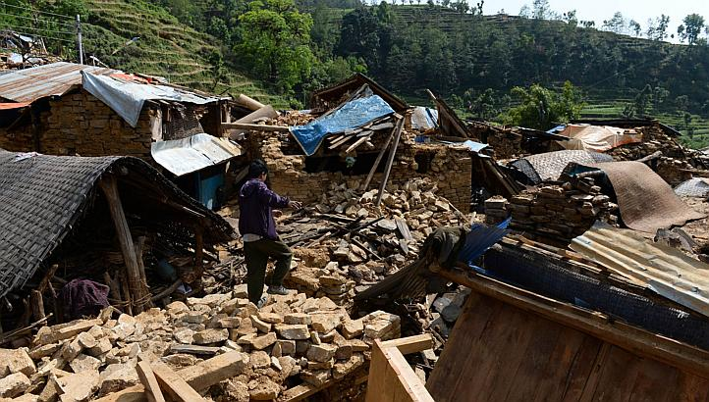
Geologists claim that Nepal is in seismic hotspot and earthquakes are likely to happen now and again in this country. The reason for the vulnerability is particularly because of the geology, orientation of the tectonic plates, and architecture.
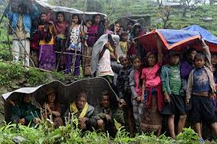
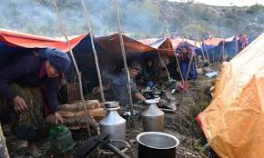
The powerful earthquake has caused extensive damage to age old historical buildings including the UNESCO enlisted heritage sites. Temples have been ruined roads destroyed thousands of people dead and many have been injured by the earthquake. Many people are still believed to be under the rubble awaiting evacuation. Hundreds of thousands of people have made homeless with entire village flattened. The earthquakes killed almost 8000 people and have injured tens of thousands. A total of 8 million people have been affected by the disaster. More than 2, 88,182 houses across Nepal have been damaged completely and more than 2, 56,694 have been partially damaged. Government buildings and schools were also damaged in great number by the massive earthquake. In total 10394 government buildings have collapsed and over 13000 were partially damaged according to Home ministry. Nearly 15,000 schools have been destroyed by the earthquake in Nepal, which could have an immeasurable effect on children's long-term futures. In Gorkha alone it is estimated that more than 90 percent of the district’s 500 schools have been destroyed or badly damaged. According to UNICEF, about 1.7 million kids are in need of urgent aid in the worst-hit areas. The earthquake had social as well as psychological effects on people. Mostly children, women and the elderly were affected by the earthquake. The earthquake had left devastating effect on the home and dwellings of the people. The poor people in the village areas are mostly affected as their houses were not robust and were vulnerable to the earthquake so when the power quake hit the country at 11:56 am NST all their houses collapsed. They are facing a great problem of re-establishing their houses.
About 90% of soldiers of Nepalese army were sent to stricken areas. It would have been impossible for the country alone to relief, rehabilitate, re-establish the people as well the country without direct and indirect international support.
Various international organizations are constantly making their endeavors to relief the earthquake victims. International agencies like Medecins Sans Frontiers (Doctors Without Borders) and Red cross were able to medically evacuate the critically wounded by helicopter from the outlying areas, initially cut off from the capital city, Kathmandu and treating others in mobile and makeshift facilities.
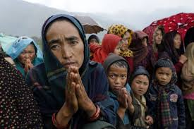
Though GONESA had been helping the earthquake victims it would have been impossible to relief the needy people from a large geographical area without the support and cooperation from VISPE, Italy. VISPE has a long history of support for child development programs in Nepal. We are very grateful to VISPE for taking immediate response towards this massive earthquake in Nepal. When GONESA got support from VISPE. We used the funding to address needs of the earthquake affected people within no time. We reached Gorkha, Lamjung and Dhading which were the most affected regions. We reached there and distributed relief package (tent, foods) which relieved them to some extent.
The quake has left thousands dead, many more injured and even more without shelter. What we know from the deadliest natural disasters in the world is that the situation only gets worse in the weeks following the event, as hospitals become overcrowded, basic supplies become scarce and those living in temporary shelters succumb to exposure and disease. GONESA provided relief packaged to the victimized. GONESA provided food packages, blankets, tents, tarpaulin, slippers, shawls etc. which is given listed as well as picture. GONESA provided not only distributed the relief package, it was provided 5o thousand rupees the prime Minister Natural disaster rescues fund by Board and staffs contribution. In addition to that VISPE ITALy Laila team directly visited injures persons in hospitals and they helped them certain goods their need in their requirement.
S.N | Supported District | Tents | Size | Food package |  |  | Quantity |  | Number of beneficiary
1 | Dhading | 150 | 18/24 | 150 pc rice/150 beaten rice |  |  | 25 k.g |  | 200 household
2 | Lamjung | 100 | 18/24 | 150pc  25k.g beaten rice |  |  | 25 k.g |  | 145 household
3. | Gorkha | 25 | 15/18 | Rice |  |  | 25kg |  | 25 household
4 | Kaski | 63 | 18/24 |  |  |  |  |  | 63 household
5 | Parbat | 250 | 15/18 |  |  |  |  |  | 250 household
6 | Syangja | 13 | 18/24 |  |  |  |  |  | 13 household
 | Support for admitted victims in Hospital
1 | Phewa city Hospital pokhara | 23 patient |  |  | Breakfast / Lunch |  |  | 2 days |  |  | 23
2 | Phewa city Hospital | 11, blanket ,1 shawl, dolls for kids |  |  |  |  |  |  |  |  | 11
3 | Gandaki Medical collage | 6o pairs slipper ,72toothpaste 72 brush and 72 soap. |  |  |  |  |  |  |  |  | 72
4

Earthquakes are unpredictable natural disaster and earthquakes like this are likely to happen now and again in this vulnerable country of ours. It mostly affects the poor people of the poor country. Mostly the dependent population (i.e. children adult and women in case of male dominant country like ours) are affected to a great extent by this type of disaster. It would have been impossible to provide relief such a large number of people without the full support and cooperation of many international agencies like VISPE.

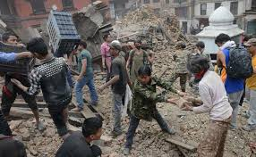  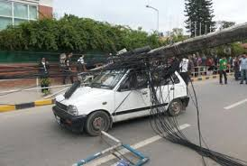  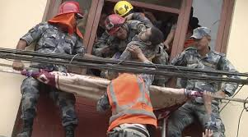  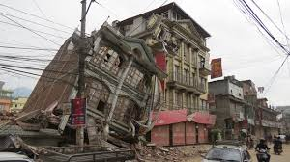 | 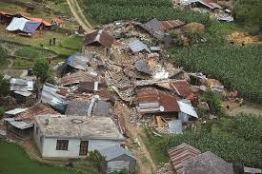  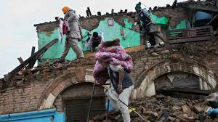  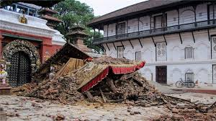  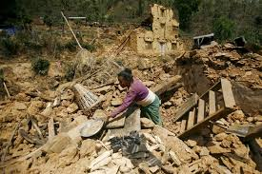 | 